Disaster Response Advisor
Team No :06
Mani Meghala .M [25MDT1019]
K. Rafiya Hanna [25MDT1044]
Abstract
Natural disasters such as floods, earthquakes, cyclones, and fires continue to threaten human life and property worldwide. Effective decision-making during emergencies is crucial, but panic and lack of preparedness often result in delayed or incorrect responses. This project proposes the design of a rule-based Expert System, Disaster Response Advisor, that provides step-by-step guidance to individuals and communities during such crises. The system employs a knowledge base consisting of predefined disaster management rules and an inference engine applying forward chaining to recommend context-appropriate actions based on user input. Inputs include the type of disaster and available resources (e.g., first aid kit, transportation, clean water), while outputs provide actionable safety instructions and emergency contact suggestions. The system is implemented in Python using the Experta/PyKnow framework and can be deployed as a console application or integrated into a web-based platform for broader accessibility. This work demonstrates the potential of expert systems in enhancing community resilience and underscores the role of artificial intelligence in improving disaster preparedness and response.

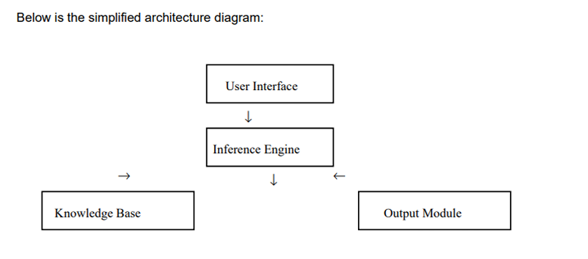

Literature Review
Expert Systems in Disaster Management
Research on Disaster Management Information Systems (DMIS) and related frameworks has highlighted the role of AI in supporting decision-making during crises. However, most systems are designed for government agencies and relief organizations, making them less accessible to individuals and communities. The proposed system focuses on user-level accessibility, bridging this gap by providing real-time personal guidance.
Rule-Based Expert Systems (MYCIN and Beyond)
Early expert systems such as MYCIN, which applied rule-based reasoning for medical diagnosis, proved the effectiveness of knowledge-driven decision support. Similar approaches are relevant in disaster scenarios, where IF–THEN rules can deliver fast, reliable, and explainable instructions under uncertain conditions.
AI in Emergency Response
AI applications in disaster research often emphasize prediction (e.g., earthquake forecasting, cyclone path modeling) and resource allocation (e.g., optimizing relief logistics). While effective, these solutions are primarily strategic. In contrast, our system targets tactical, user level decision-making, providing actionable steps tailored to the immediate context.
Knowledge Representation and Inference
The success of expert systems depends on structured knowledge representation and robust inference mechanisms. Rule-based representation offers transparency and speed, making it well-suited for emergencies where time-sensitive reasoning is critical. Forward chaining enables proactive recommendations based on evolving user inputs.
Gaps in Existing Solutions
Existing mobile disaster applications, such as the Red Cross Emergency App, primarily offer alerts and static guidelines. They lack adaptive reasoning that considers a user’s specific situation and available resources. By combining context-aware recommendations with a rule-based inference engine, the proposed Disaster Response Advisor addresses this limitation, enhancing practicality and life-saving potential.

Introduction
Disasters, both natural and artificial, often occur unexpectedly and cause significant damage to life and property. In such critical situations, individuals require immediate and accurate information to take safety measures. Traditional disaster management systems depend heavily on manual processes and human intervention, leading to delayed responses and communication breakdowns. The increasing frequency of disasters demands intelligent systems that can guide individuals instantly based on their situation.
This project presents a rule-based expert system that applies artificial intelligence to disaster response. By inputting their current conditions—such as being indoors or outdoors, having access to first-aid, and proximity to affected areas—users receive tailored safety advice. The integration of AI reasoning and a user-friendly interface ensures that this system can serve as a practical, real-time decision support tool during emergencies.

Existing System:
In the current scenario, disaster management systems primarily rely on human coordination and manual decision-making. People affected by natural or man-made disasters depend heavily on helpline numbers, official broadcasts, or emergency centers to obtain guidance. This traditional approach often results in delays, miscommunication, and lack of personalized advice. Existing systems mainly focus on collecting and reporting data related to the disaster rather than providing immediate, situation-specific instructions to individuals.
Furthermore, these systems are not capable of adapting to different disaster types or user conditions. In emergency situations, the absence of quick, automated decision support leads to panic and confusion, ultimately increasing the risk to life and property. Thus, there is a strong need for an intelligent system that can provide real-time, personalized, and accurate safety advice during emergencies without relying on human intervention.

Proposed System:
The proposed system, titled Disaster Response Advisor using Artificial Intelligence, aims to overcome the limitations of the existing manual disaster management approach. It is designed as an AI-based expert system capable of providing real-time safety recommendations based on the user’s situation. The system utilizes rule-based reasoning techniques to infer safety actions that a person should take during different disasters such as earthquakes, floods, fires, cyclones, tsunamis, landslides, droughts, and pandemics.
The user interacts with the system through a simple and intuitive web interface built using Streamlit. After selecting the disaster type and answering questions about their current situation (for example, whether they are indoors, have access to clean water, or if there are injured people nearby), the system uses its AI inference engine to generate relevant safety guidelines. This intelligent system can therefore assist individuals in making informed and quick decisions during emergencies, ultimately improving disaster response efficiency and reducing panic.

Methodology
The development of this project follows the Expert System methodology, which is a subfield of Artificial Intelligence focused on imitating human expert reasoning. The methodology includes several key stages:
Initially, the problem was identified as the lack of immediate and personalized safety guidance during disasters. Following that, the knowledge acquisition phase involved collecting safety procedures and best practices from reliable sources such as the United Nations Disaster Risk Reduction (UNDRR), the World Health Organization (WHO), and national disaster management authorities. This knowledge was then represented in the form of IF–THEN rules, which form the core of the system’s knowledge base.
The knowledge representation process involved converting expert knowledge into structured rules. For example, “IF the disaster is an earthquake AND the user is indoors, THEN advise the user to drop, cover, and hold on.” These rules were implemented using the Experta library in Python.
The inference mechanism is implemented through Experta’s forward chaining reasoning process. This mechanism begins with known facts, i.e., user inputs, and iteratively applies relevant rules to infer safety actions. Finally, the user interface was designed using the Streamlit framework to allow easy interaction between the system and the user. The system was tested across various disaster scenarios to ensure that the rules trigger appropriate and accurate recommendations.

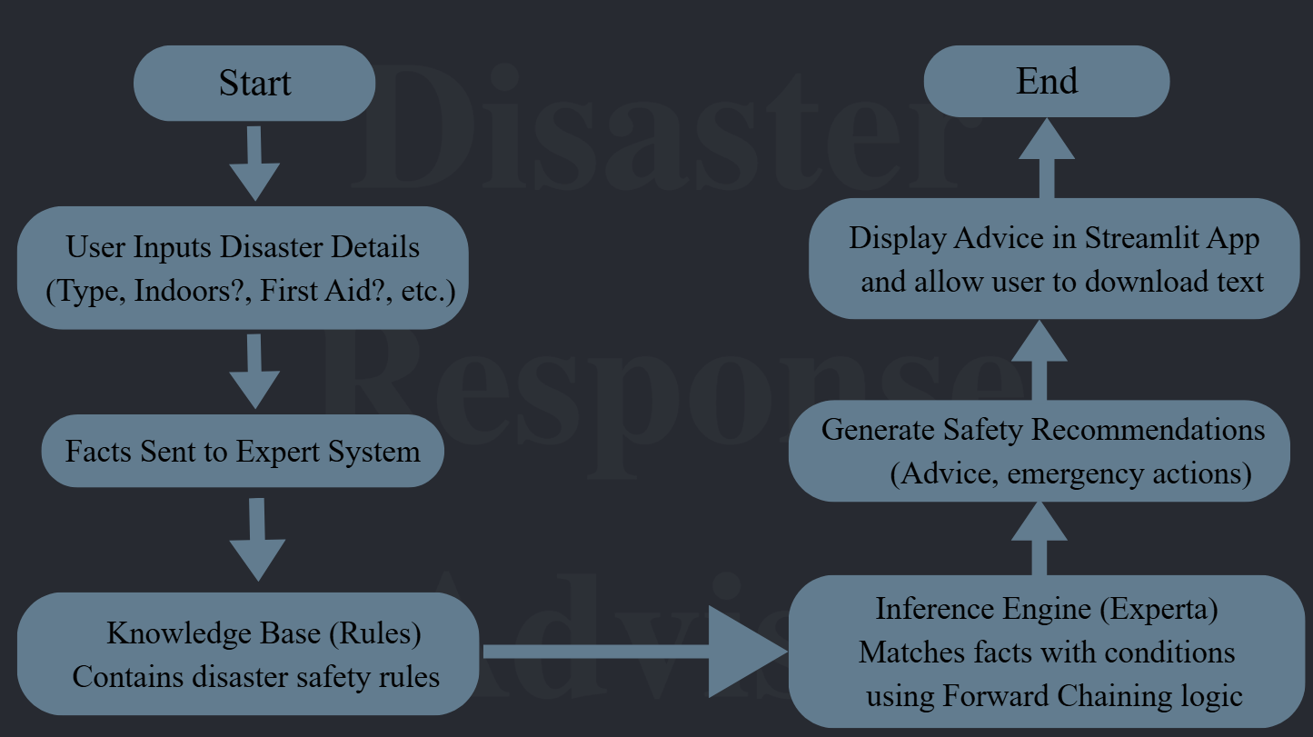
Figure 1: Flow of the Disaster Response Advisor System

Output Screenshots

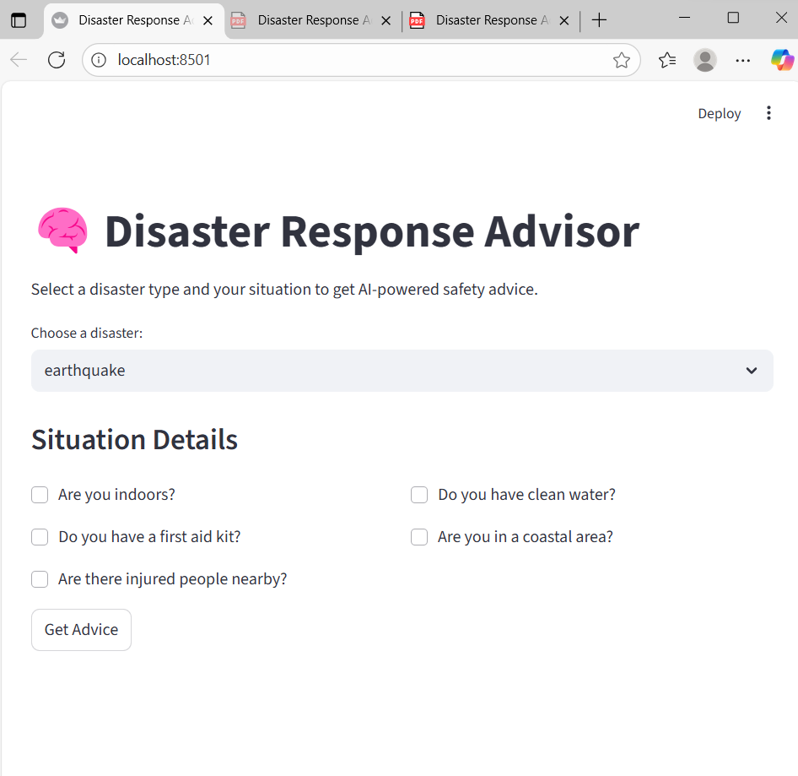
Figure 2: Streamlit Home Screen
(Screenshot of the home interface with project title)

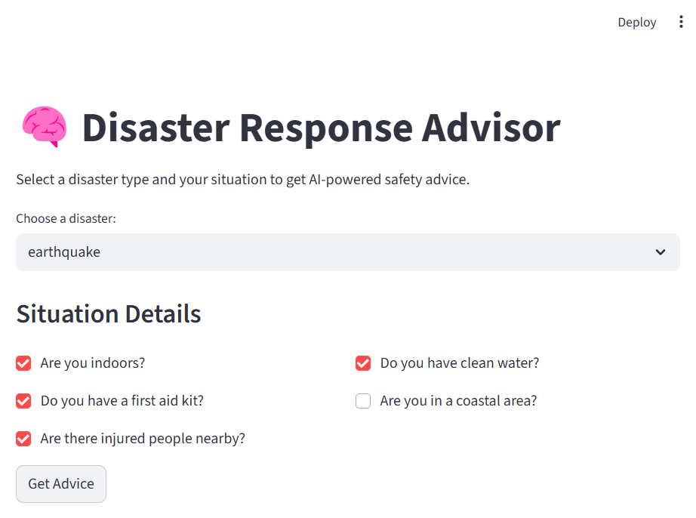
Figure 3: User Input Section
(Screenshot showing disaster selection and input options)

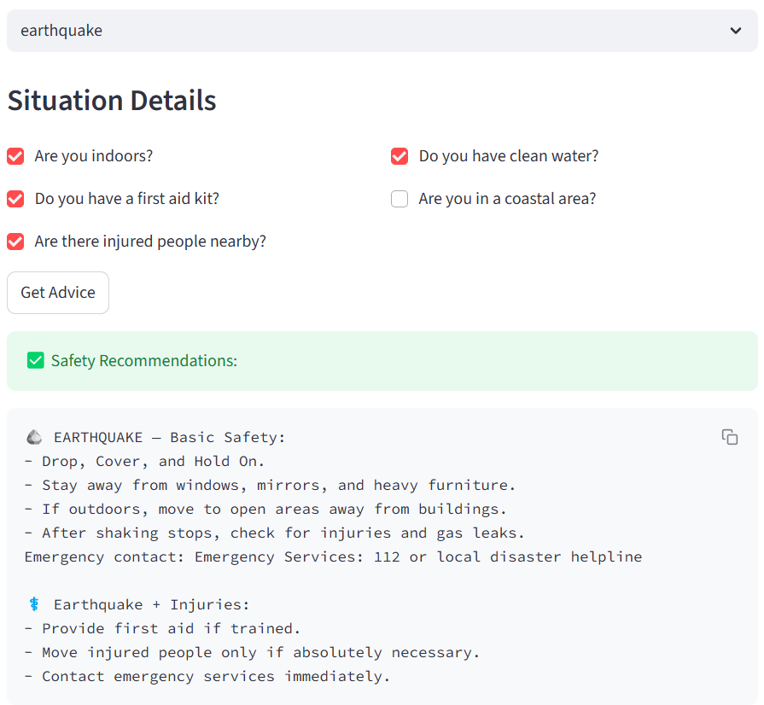
Figure 5: Output Section
(Screenshot showing safety recommendations generated by the AI engine)

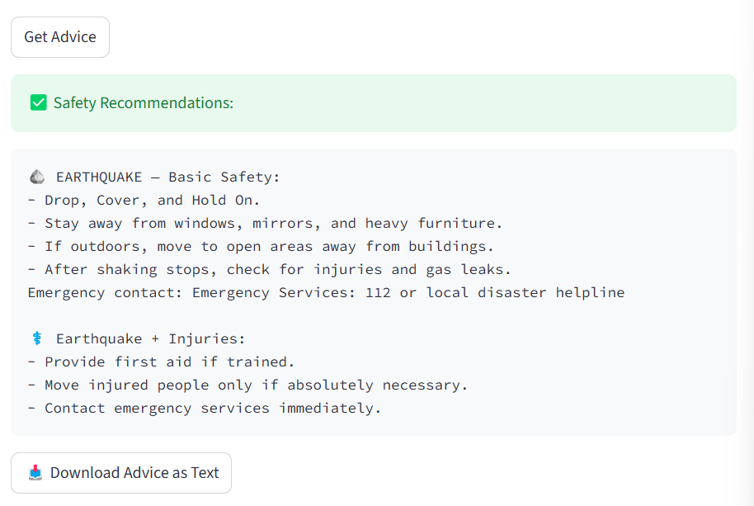
Figure 6: Download Button
(Screenshot showing option to download advice as text file)

Results and Discussion
The Disaster Response Advisor successfully generates personalized safety recommendations based on user input. The AI reasoning engine correctly interprets conditions such as disaster type, user location, and available resources. The system’s modular structure allows additional disaster types and rules to be added easily. Test cases for multiple scenarios, including earthquake, flood, and fire, produced accurate and contextually appropriate advice. The Streamlit interface further enhances user accessibility by presenting information clearly and intuitively.

Future Enhancements
The current system can be expanded in several directions. Integration of voice-based input would allow users to interact hands-free during emergencies. Linking with GPS could enable location-based advice and automatic detection of regional hazards. Incorporating IoT sensors could help detect environmental parameters such as tremors, water levels, or smoke. Additionally, multilingual support and connection to emergency service APIs could make the system more inclusive and functional in real-world disaster response networks.

Conclusion
The Disaster Response Advisor using Artificial Intelligence demonstrates the practical application of expert systems in real-world disaster management. By combining rule-based reasoning with a user-friendly interface, the system effectively provides personalized, accurate, and real-time safety recommendations. Unlike traditional systems that depend on human operators, this AI-driven approach automates decision-making and enhances the speed and precision of responses during emergencies. The modular and extensible design ensures that the system can evolve with future technological advancements, ultimately contributing to safer and more informed communities.

